# ML Lab 1
## Name: Saptanshu Wanjari
### Class: A-A2
### Roll No: 18
Lab No. | 1
Lab Aim and Objective | To study and apply data preprocessing techniques on a given dataset and to prepare the Titanic dataset for training with a machine learning algorithm by cleaning the data, handling missing values, encoding categorical features, removing outliers, scaling features and splitting the data into training and testing sets.
Dataset or Resources Used | Titanic dataset (titanic.csv, 891 passenger records). Tools: Python 3, Jupyter Notebook, pandas, NumPy, Matplotlib, Seaborn and scikit-learn.
Date of Performance | 08 July 2026

1. Theory
1.1 What is Data Preprocessing?
Data preprocessing is the process of converting raw data into a clean, consistent and usable format before it is given to a machine learning model. Raw data collected from the real world is often incomplete, noisy, inconsistent and contains redundancies. A model trained on such data learns incorrect patterns and performs poorly. Preprocessing improves data quality, reduces training time and increases model accuracy. It is one of the most important stages of any machine learning pipeline.
1.2 Techniques Applied in this Lab
The following preprocessing techniques were studied and applied to the Titanic dataset:
• Data Cleaning – handling missing values in the Age and Embarked columns by imputation (median and mode), and removing duplicate rows.
• Data Transformation – converting the categorical columns Sex and Embarked into numeric form using Label Encoding / mapping, and standardising the numeric features Age and Fare with StandardScaler.
• Handling Outliers – detecting outliers in Age and Fare using box plots and removing them with the Inter-Quartile Range (IQR) rule.
• Data Reduction – dropping irrelevant columns (PassengerId, Name, Ticket, Cabin) that do not help the model predict survival.
• Data Splitting – dividing the cleaned dataset into training (80%) and testing (20%) sets so the model can be trained and evaluated on unseen data.
1.3 About the Dataset
The Titanic dataset contains the passenger manifest of the RMS Titanic. Each row is a passenger with attributes such as PassengerId, Pclass, Name, Sex, Age, SibSp, Parch, Ticket, Fare, Cabin and Embarked. The target variable Survived is 1 if the passenger survived the sinking and 0 otherwise. The goal of any model built on this data is to predict whether a passenger survived, based on the remaining features.

2. Code with GitHub URL
The complete code for this lab is written in a Jupyter Notebook and uploaded to GitHub. The notebook is available at the following URL:
https://github.com/SaptanshuWanjari/3rd-Year-/blob/main/ML/lab/8-7-Lab-1/Lab_1_A_18_Saptanshu_Wanjari.ipynb
https://github.com/SaptanshuWanjari/3rd-Year-/blob/main/ML/lab/8-7-Lab-1/Lab_1_A_18_Saptanshu_Wanjari.py
The complete written code is given below:
#!/usr/bin/env python
# coding: utf-8
# # Lab 1: Data Preprocessing on the Titanic Dataset
#
# **Course:** Machine Learning &nbsp;|&nbsp; **Section:** A &nbsp;|&nbsp; **Roll No:** 18 &nbsp;|&nbsp; **Name:** Saptanshu Wanjari &nbsp;|&nbsp; **Batch:** A2
#
# This notebook prepares the Titanic dataset for training a machine learning model by applying
# standard data preprocessing techniques.
# ## Aim
# To study and apply data preprocessing techniques on the Titanic dataset so that it becomes
# clean, consistent and ready for training a machine learning algorithm.
# In[1]:
import numpy as np
import pandas as pd
import matplotlib.pyplot as plt
import seaborn as sns
from sklearn.model_selection import train_test_split
from sklearn.preprocessing import LabelEncoder, StandardScaler
get_ipython().run_line_magic('matplotlib', 'inline')
# ## Step 1: Loading the Dataset
# We load the `titanic.csv` file into a pandas DataFrame and inspect its structure.
# In[2]:
df = pd.read_csv("titanic.csv")
print("Dataset shape:", df.shape)
df.head()
# In[3]:
df.tail()
# In[4]:
df.info()
# In[5]:
df.describe()
# ## Step 2: Handling Missing Values
# First we check how many missing values each column contains. The `Age` and `Embarked` columns
# have null entries. `Cabin` is mostly missing, so it will be dropped later.
# In[6]:
df.isnull().sum()
# In[7]:
df["Embarked"].unique()
# In[8]:
df["Embarked"] = df["Embarked"].map({"S": 0, "C": 1, "Q": 2})
print(df["Embarked"].value_counts())
# In[9]:
df["Age"] = df["Age"].fillna(df["Age"].median())
df["Embarked"] = df["Embarked"].fillna(df["Embarked"].mode()[0])
print("Missing values after filling:")
df.isnull().sum()
# ## Step 3: Removing Irrelevant Columns
# Columns that carry no predictive value (IDs, names, ticket numbers) or that are mostly
# missing (`Cabin`) are removed from the dataset.
# In[10]:
df.drop(columns=["PassengerId", "Name", "Ticket", "Cabin"], inplace=True)
print("Shape after dropping columns:", df.shape)
# ## Step 4: Handling Duplicate Rows
# Duplicate rows add no information and can bias the model, so they are detected and removed.
# In[11]:
print("Duplicate rows before removal:", df.duplicated().sum())
df.drop_duplicates(inplace=True)
print("Shape after removing duplicates:", df.shape)
# ## Step 5: Detecting and Removing Outliers
# Box plots are used to detect outliers in the `Age` and `Fare` columns, which are then removed
# using the Inter-Quartile Range (IQR) rule.
# In[12]:
fig, axes = plt.subplots(1, 2, figsize=(11, 4))
sns.boxplot(x=df["Age"], ax=axes[0]).set_title("Box Plot of Age")
sns.boxplot(x=df["Fare"], ax=axes[1]).set_title("Box Plot of Fare")
plt.tight_layout()
plt.show()
# In[13]:
for col in ["Age", "Fare"]:
Q1, Q3 = df[col].quantile(0.25), df[col].quantile(0.75)
IQR = Q3 - Q1
lower, upper = Q1 - 1.5 * IQR, Q3 + 1.5 * IQR
df = df[(df[col] > lower) & (df[col] < upper)]
print("Shape after removing outliers:", df.shape)
# In[14]:
fig, axes = plt.subplots(1, 2, figsize=(11, 4))
sns.boxplot(x=df["Age"], ax=axes[0]).set_title("Age after outlier removal")
sns.boxplot(x=df["Fare"], ax=axes[1]).set_title("Fare after outlier removal")
plt.tight_layout()
plt.show()
# ## Step 6: Encoding Categorical Features
# Machine learning algorithms work with numbers, so the text columns `Sex` and `Embarked`
# are converted into numeric form using `LabelEncoder`.
# In[15]:
le = LabelEncoder()
df["Sex"] = le.fit_transform(df["Sex"])
print("Data types after encoding:")
df.dtypes
# In[16]:
df.head()
# ## Step 7: Exploratory Data Analysis
# Visualising the data helps us understand the class distribution and the relationship
# between the features and the target variable `Survived`.
# In[17]:
sns.countplot(x="Survived", data=df)
plt.title("Count of Survived vs Not Survived")
plt.show()
# In[18]:
sns.countplot(x="Sex", hue="Survived", data=df)
plt.title("Survival by Gender")
plt.show()
# In[19]:
sns.histplot(df["Age"], kde=True)
plt.title("Distribution of Age")
plt.show()
# In[20]:
sns.histplot(df["Fare"], kde=True)
plt.title("Distribution of Fare")
plt.show()
# In[21]:
sns.scatterplot(x="Age", y="Fare", data=df)
plt.title("Age vs Fare")
plt.show()
# In[22]:
plt.figure(figsize=(9, 6))
sns.heatmap(df.corr(), annot=True, cmap="coolwarm", fmt=".2f")
plt.title("Correlation Heatmap")
plt.show()
# ## Step 8: Feature Scaling
# `Age` and `Fare` are measured on very different scales. Standardization gives both features
# a mean of 0 and a standard deviation of 1.
# In[23]:
scaler = StandardScaler()
df[["Age", "Fare"]] = scaler.fit_transform(df[["Age", "Fare"]])
print("Mean of Age after scaling:", round(df["Age"].mean(), 4))
print("Std of Age after scaling:", round(df["Age"].std(), 4))
print("Mean of Fare after scaling:", round(df["Fare"].mean(), 4))
print("Std of Fare after scaling:", round(df["Fare"].std(), 4))
# In[24]:
df.head()
# ## Step 9: Train-Test Split
# The cleaned dataset is split into training and testing sets. The model will be trained on
# 80% of the data and evaluated on the remaining 20%.
# In[25]:
X = df.drop("Survived", axis=1)
y = df["Survived"]
X_train, X_test, y_train, y_test = train_test_split(X, y, test_size=0.2, random_state=42)
print("X_train shape:", X_train.shape)
print("X_test shape:", X_test.shape)
print("y_train shape:", y_train.shape)
print("y_test shape:", y_test.shape)
# ## Conclusion
# The Titanic dataset has been successfully preprocessed:
#
# - Missing values in `Age` (filled with median) and `Embarked` (filled with mode) were handled.
# - Irrelevant columns (`PassengerId`, `Name`, `Ticket`, `Cabin`) and duplicate rows were removed.
# - Outliers in `Age` and `Fare` were removed using the IQR rule.
# - Categorical columns `Sex` and `Embarked` were label-encoded into numbers.
# - `Age` and `Fare` were standardized using `StandardScaler`.
# - The data was split into training (80%) and testing (20%) sets.
#
# The resulting dataset is now clean, numeric and scaled, and is ready for training a machine
# learning model.

3. Procedures and Materials Used
3.1 Materials Used
• Hardware: Personal computer / laptop.
• Software: Python 3, Jupyter Notebook (JupyterLab), web browser.
• Python libraries: pandas, NumPy, Matplotlib, Seaborn, scikit-learn.
• Dataset: titanic.csv (891 records) obtained from the Kaggle Titanic competition.
3.2 Procedure
1. Load the Titanic dataset using pandas and inspect it with head(), tail(), info() and describe().
2. Check for missing values using isnull().sum().
3. Handle missing values: fill Age with the median and Embarked with the mode.
4. Drop irrelevant columns (PassengerId, Name, Ticket, Cabin).
5. Detect and remove duplicate rows using duplicated() and drop_duplicates().
6. Detect outliers in Age and Fare with box plots and remove them using the IQR rule.
7. Encode categorical features: map Embarked (S, C, Q to 0, 1, 2) and label-encode Sex.
8. Visualise the data (survival counts, histograms, scatter plot, correlation heatmap).
9. Scale the numeric features Age and Fare using StandardScaler.
10. Split the data into training (80%) and testing (20%) sets using train_test_split.
11. Record all outputs as screenshots and prepare this report.

4. Output Screenshots with Descriptions
Output 1 – Loading the Dataset (df.head())
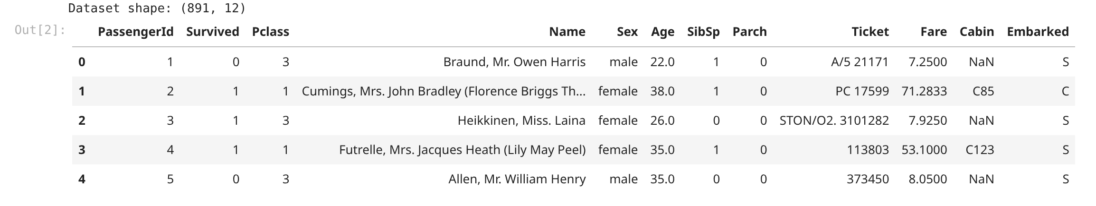
This is df.head() which shows the first 5 rows of the dataset. The data has 12 columns and 891 rows. Cabin column is mostly empty, so there are missing values. Some columns like Name, Ticket and PassengerId are not useful for prediction.
Output 2 – Dataset Information (df.info())
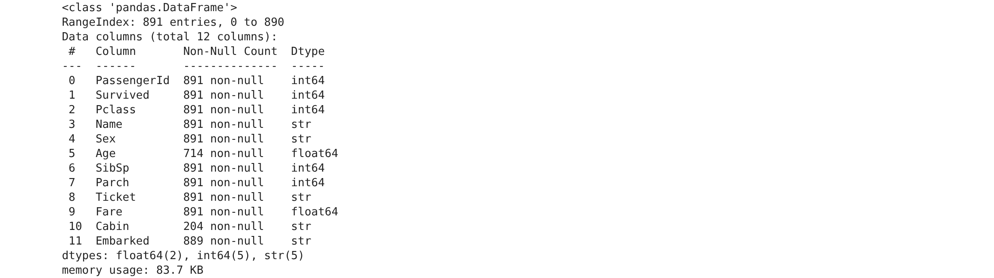
df.info() gives the summary of the dataframe. It shows the non-null counts and data types. Age has only 714 values, Cabin has 204 and Embarked has 889 out of 891. So these 3 columns have missing data. The object type columns will need encoding later.
Output 3 – Missing Values Before Cleaning
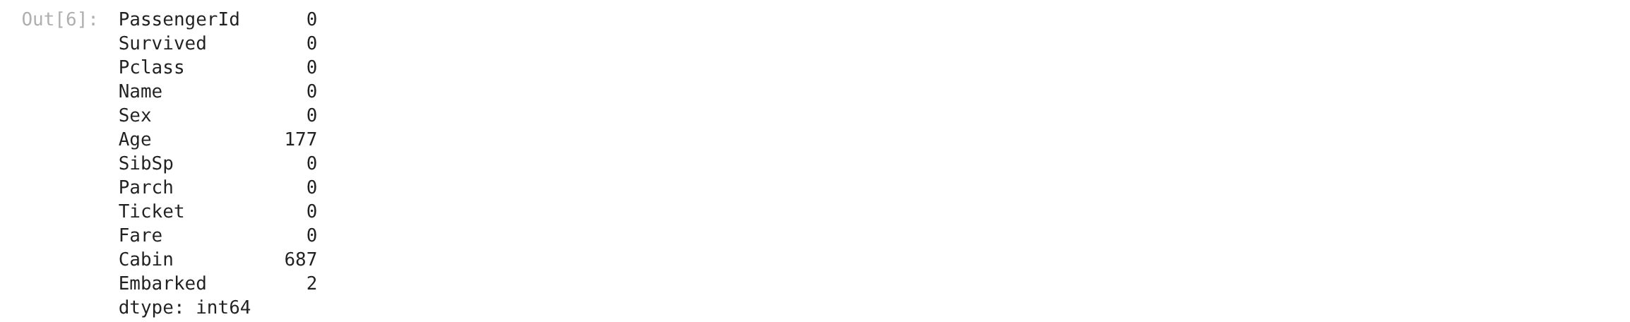
This shows the total missing values in each column. Age is missing 177 values, Cabin is missing 687 and Embarked is missing only 2. Since Cabin is 77% empty we dropped it. Age and Embarked will be filled using imputation.
Output 4 – Missing Values After Imputation
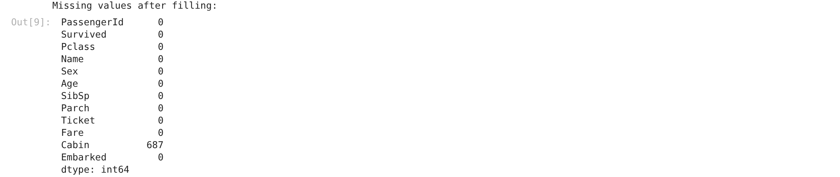
After filling the missing values we checked again. Now every column shows 0 missing values. Age was filled with the median and Embarked with the most common value (mode). So now there is no null data left in the dataset.
Output 5 – Handling Duplicate Rows
We found 116 duplicate rows in the dataset. Duplicates do not give any new information, so we removed them. After dropping duplicates the dataset has 775 rows. This keeps the model from giving extra weight to repeated records.
Output 6 – Outlier Detection Using Box Plots
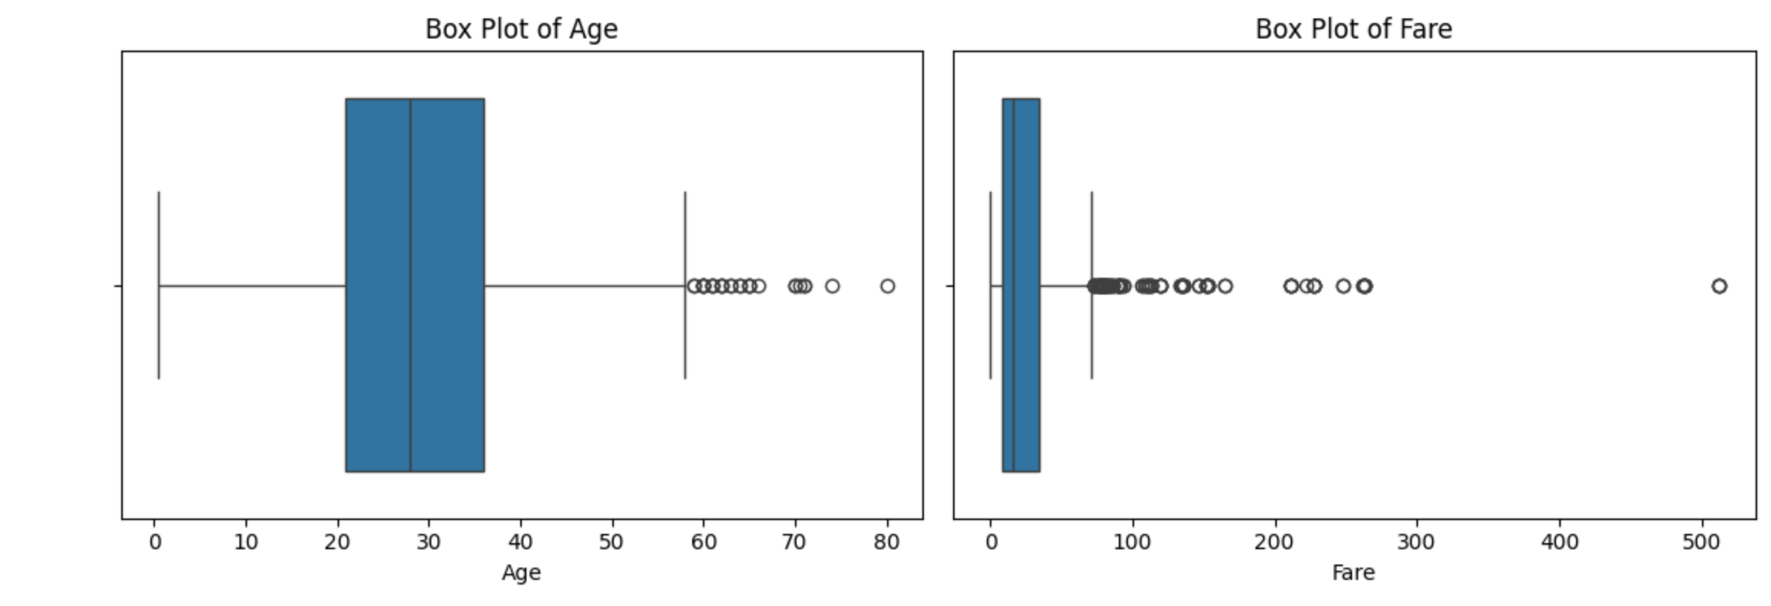
Box plots of Age and Fare to find outliers. The dots outside the whiskers are outliers. Fare has many high value outliers. Age has a few extreme values on both sides. These outliers are removed using the IQR method in the next step.
Output 7 – Box Plots After Outlier Removal
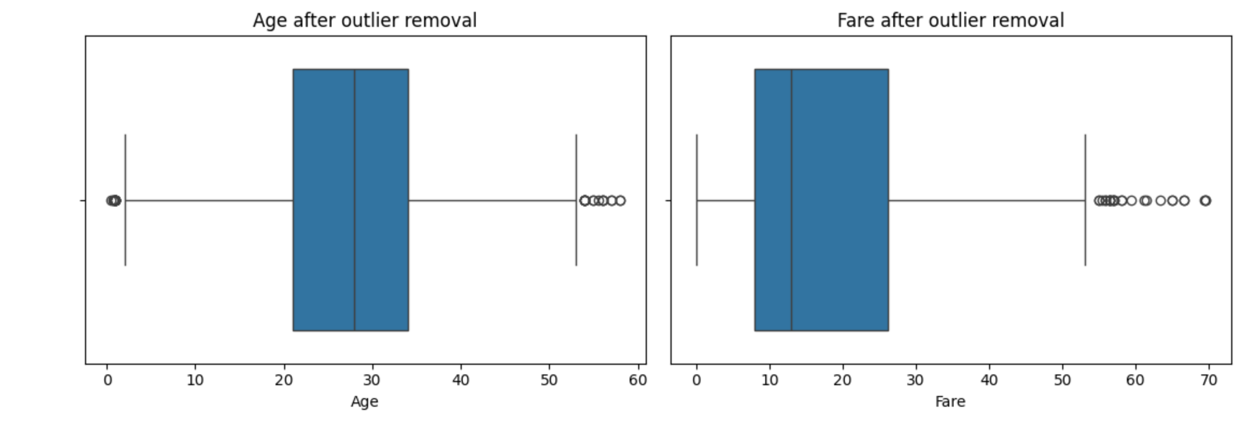
Box plots again after removing the outliers using the IQR rule. Now there are no points outside the whiskers. The dataset went from 775 rows to 649 rows. Removing outliers makes the data more reliable for the model.
Output 8 – Encoded Categorical Data (df.head())
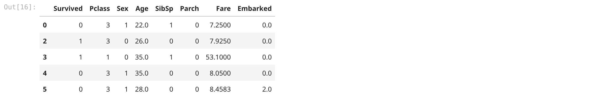
This is the data after encoding. Sex now has 0 and 1 instead of male and female. Embarked has 0, 1, 2 instead of S, C, Q. Every column is now numeric so it can be used by machine learning algorithms. The unwanted columns are also removed now.
Output 9 – Distribution of the Target Variable
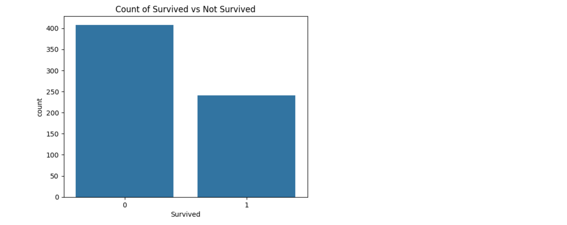
Count plot of the Survived column. More people died than survived in the dataset. This means the data is a bit imbalanced. Knowing the class distribution helps to choose the right evaluation metric later. No extra step is needed for now.
Output 10 – Correlation Heatmap
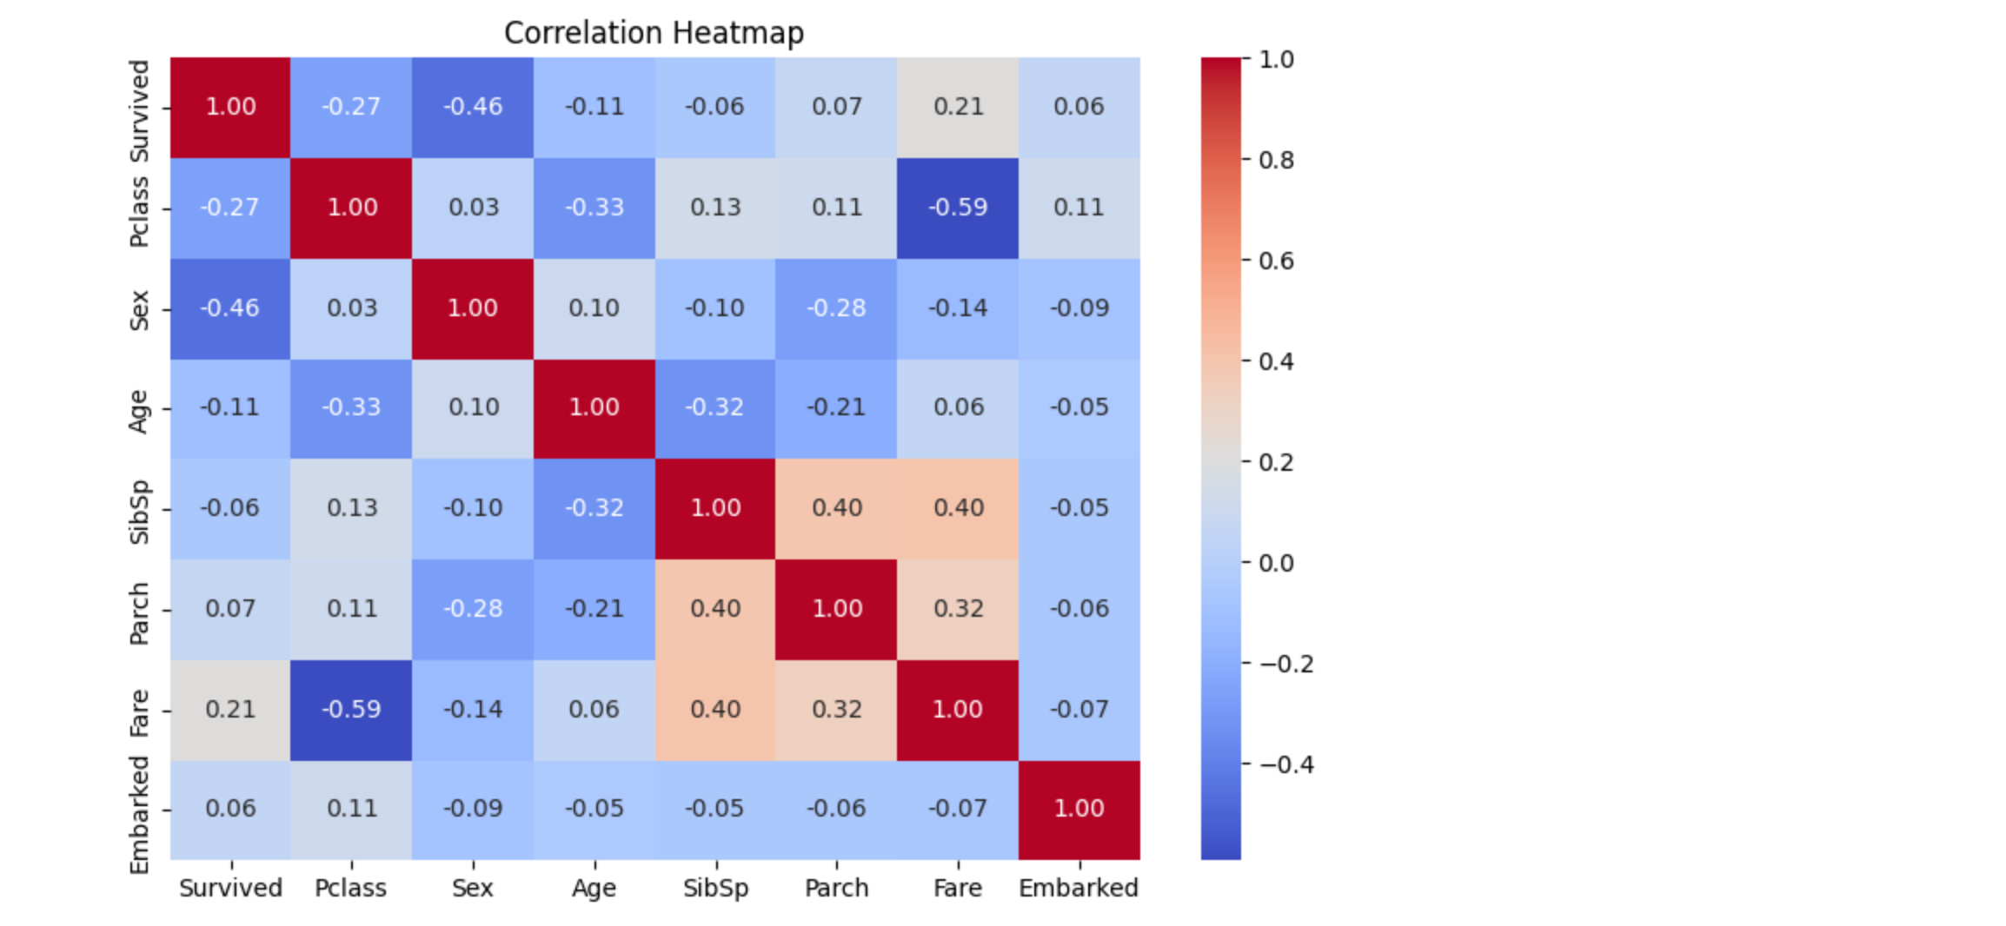
Correlation heatmap of all numeric columns. Survived is negatively related to Pclass, so passengers in 1st class survived more. Fare and Pclass are strongly related because higher class tickets cost more. This helps us understand which features matter for survival.
Output 11 – Feature Scaling (StandardScaler)
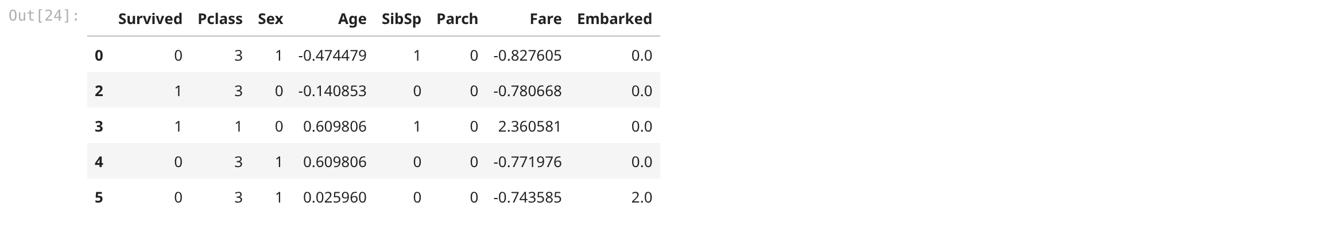
After scaling, Age and Fare now have mean around 0 and std around 1. The values are centered around zero. Scaling is needed so that Fare (which has large values) does not dominate Age. The head shows the scaled dataframe.
Output 12 – Train-Test Split
The data is split into train and test using test_size 0.2. X_train has 519 rows and 7 features, X_test has 130 rows. 80% data is for training and 20% is for testing. The dataset is now ready for training a machine learning model.

5. Viva Questions and Solutions
Q1. What is data preprocessing and why is it important in machine learning?
Solution: Data preprocessing is the process of transforming raw data into a clean, consistent and usable format before feeding it to a model. Raw data is often incomplete, noisy and inconsistent, which degrades model performance. Preprocessing improves data quality, reduces training time and increases accuracy. It includes handling missing values, removing duplicates and outliers, encoding categorical variables, scaling features and splitting data into training and testing sets.
Q2. How did you handle the missing values in the Age and Embarked columns, and why those methods?
Solution: Age had 177 missing values and was filled with the median age because Age is a numerical column that may contain outliers, so the median is more robust than the mean. Embarked had 2 missing values and was filled with the mode, i.e. the most frequent port (S), because it is a categorical column. Imputation was preferred over deleting the rows because the missing proportion is low and deleting rows would lose useful information.
Q3. Differentiate between Label Encoding and One-Hot Encoding. Which one did you use and why?
Solution: Label Encoding assigns a unique integer to each category, e.g. male→0 and female→1. One-Hot Encoding creates a separate binary column for every category. Label Encoding is compact but can imply an artificial order between categories; One-Hot Encoding avoids that but increases dimensionality. In this lab, Label Encoding was used for Sex (two categories) and a mapping was used for Embarked (S, C, Q → 0, 1, 2) to keep the feature set small and numeric.
Q4. What is the IQR method for outlier detection and how does it work?
Solution: The Inter-Quartile Range (IQR) is the difference between the third quartile (Q3) and the first quartile (Q1) of the data. A value is considered an outlier if it lies below Q1 − 1.5×IQR or above Q3 + 1.5×IQR. Outliers were first visualised using box plots and then removed by filtering out rows outside these limits. In this lab the IQR rule reduced the dataset from 775 to 649 rows. Removing outliers prevents extreme values from skewing the model.
Q5. Why is feature scaling required, and what is the difference between Standardization and Min-Max Normalization?
Solution: Features such as Age and Fare are measured on different scales, and a feature with a larger range can dominate distance computations in algorithms like KNN, SVM and linear models. Standardization (StandardScaler) rescales a feature to mean 0 and standard deviation 1 using (x − mean)/std, and it is not bounded to a fixed range. Min-Max Normalization rescales values to a fixed range, usually [0, 1], using (x − min)/(max − min). In this lab StandardScaler was applied, and the output confirmed that Age and Fare have a mean of 0 and a standard deviation of 1.

